**Object-Oriented Programming**

Laboratory Activity No. 1

**Review of Technologies**

*Submitted by:*

**Vasig,Yuan Hessed O.**

**Sat 12:00-4:00pm/4:30-8:30pm / BSCpE 1-A**

*Submitted to*

**Maria Rizette H. Sayo**

Instructor

*Date Performed:*

**18-01-2025**

*Date Submitted*

**18-01-2025**

I. Objectives

In this section, the goals in this laboratory are:

* To define the key terms in Object-oriented programming
* To be able to know the construction of OOP concepts in relation to other types of programming such as procedural or functional programming

II. Methods

General Instruction:

1. Define and discuss the following Object-oriented programming concepts:
2. Classes

* A class is an object creation blueprint or template. It defines a set of properties that the class-derived objects must possess. It acts as a framework or prototype for an object of that class to follow. Classes describe related objects, they are like blueprints for creating an object (Lott and Phillips 2021)

1. Objects

* An object is a collection of data with associated behaviors (Lott and Philips 2021). An instance of a class is called an object. After a class is defined, objects are then created from it, and each object has its own data (fields or attributes). The objects in OOP can also execute methods within that class.

1. Fields

* are the variables that belong to a class. They store the data for the objects created from the class. Fields represent the state of an object.

1. Methods

* are functions that are defined within a class and define the behaviors of the objects created from that class. Methods can access and modify the fields of the class

.

1. Properties

* are a way to define getter and setter methods in a more concise way in OOP, especially in languages like Python, which allow you to use properties as attributes without needing explicit method calls. A property allows you to manage access to private fields more safely.

III. Results

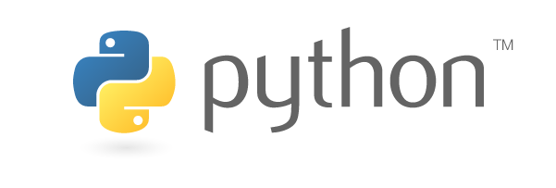

Figure 1: Python Logo

Source: [The Python Logo | Python Software Foundation](https://www.python.org/community/logos/)

Python is by definition a widely used high-level programming language for general purpose coding.It is a strong and flexible programming language that corresponds strictly to its principles of object-oriented programming (OOP). The OOP paradigm divides code into reusable objects with methods (functions) and attributes (data). Python is a great option for efficiently and naturally applying OOP concepts because of its architecture and grammar.

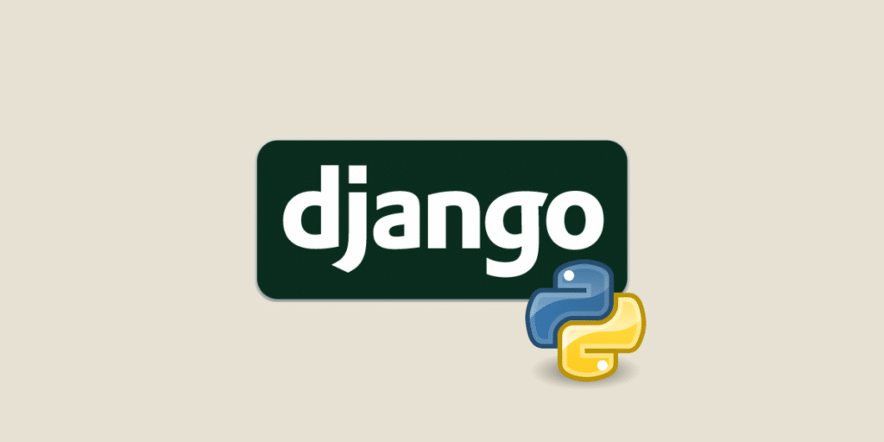

Figure 2: Django, one of python’s framework

Source: [Django : Tout sur le framework de développement web en Python](https://datascientest.com/django-tout-savoir)

Python's vast libraries and frameworks, such as Django, TensorFlow, and Pandas, enable a wide range of applications, including web development, data research, machine learning, automation, and artificial intelligence. In addition, it is platform-independent, meaning that code can run on many operating systems, and it allows object-oriented programming, which improves code organization and reusability. Python has emerged as a vital tool in contemporary software development and is still in high demand due to its robust community support, superior integration features, and growing industry use.

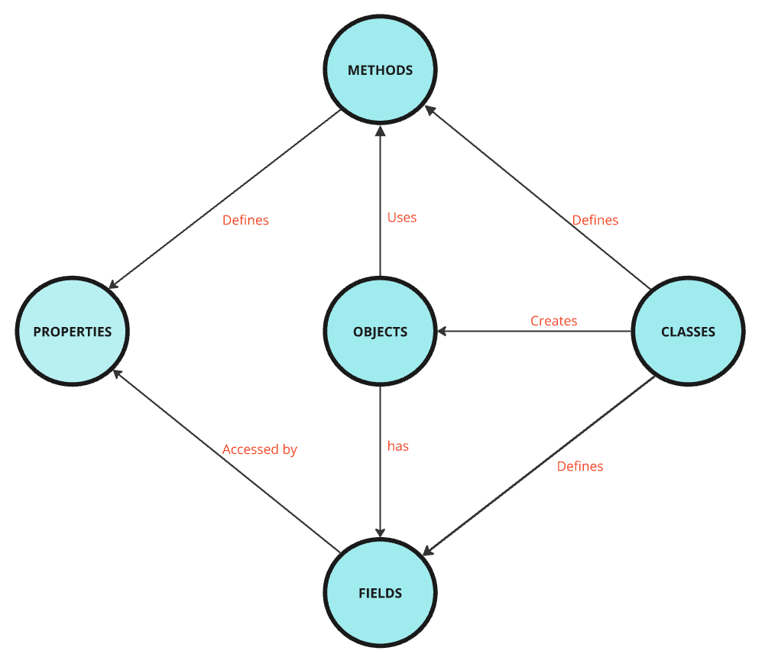

*Figure 3: Relationships between Methods, Objects, Classes, Properties and Fields*

**Classes:**

* Blueprint for creating objects.
* Relationships:
  + Creates Objects.
  + Defines Fields (data) and Methods (behavior).

**Objects:**

* Instances of classes.
* Relationships:
  + Have Fields for unique data.
  + Use Methods for actions.

**Fields:**

* Variables belonging to an object or class, holding relevant data.
* Relationships:
  + Accessed and modified via Properties.

**Methods:**

* Functions within a class, describing object behavior.
* Relationships:
  + Define Properties for controlled field access.

**Properties:**

* Special methods (getters/setters) managing field access.
* Relationships:
  + Access Fields via controlled interfaces.

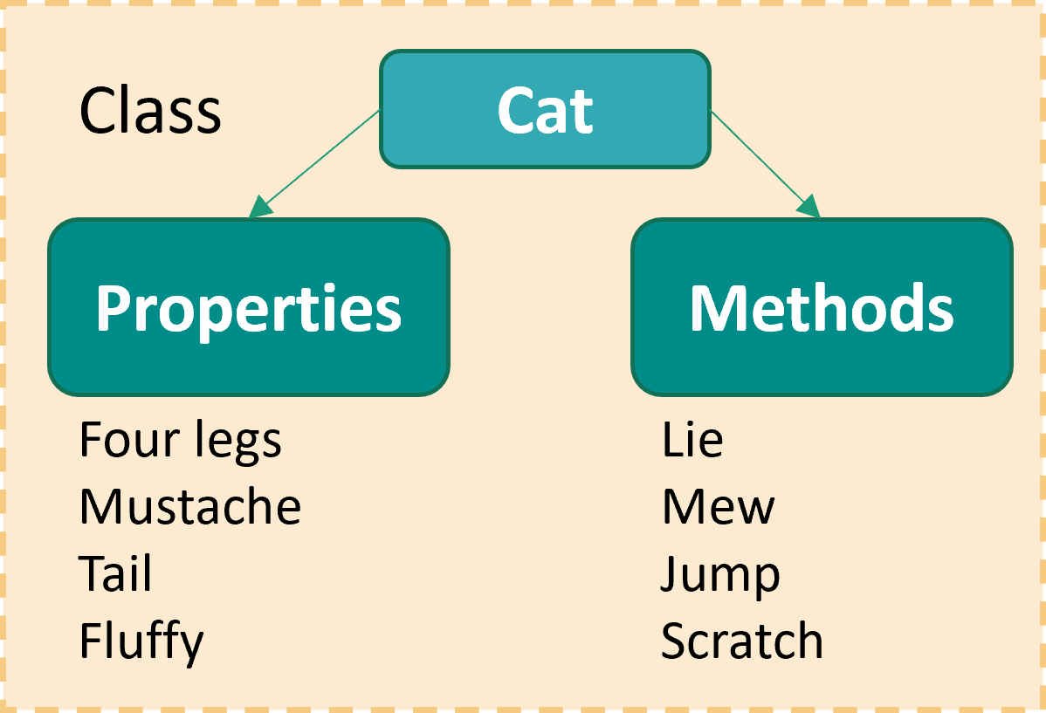

*Figure 4:* ***Object-Oriented Programming (OOP)*** *concept class structure*

*Source:* [*Python. Object-oriented programming (OOP). Classes (en) - Programming languages - Algorithms & Programming - Каталог статей - BZFAR*](https://www.bzfar.org/publ/algorithms_programming/programming_languages/python_classes/42-1-0-182)

- **Class** (Cat): A blueprint that defines both the **properties** (attributes) and **methods** (actions) for all objects of that type.

- **Properties**: Represent the state of the object. For example, all cats have "four legs" or "a tail."

- **Methods**: Represent the behavior of the object. For instance, a cat can "mew" or "jump."

IV. Conclusion

Classes, objects, fields, methods, and properties are some of the basic ideas of object-oriented programming (OOP) that we studied in this lab and understand how OOP organizes code and enables modular, reusable, and maintainable software development requires a grasp of these fundamental ideas. We built a class as a template for building things, with fields holding their data and methods defining how they should behave. Properties provide a clear method of controlling access to these fields, guaranteeing that objects engage with their state in a regulated fashion.  
  
 We also looked at how these OOP elements relate to one another, including how classes construct objects, which subsequently employ methods to carry out operations and handle data through fields. Properties improve code safety and flexibility by granting controlled access to these fields.

*.*

**Reference**

**Book**

[1] S. F. Lott and D. Phillips, *Python Object-Oriented Programming*. Packt Publishing Ltd, 2021.

**Website**

[2] “Python. Object-oriented programming (OOP). Classes (en) - Programming languages - Algorithms & Programming - Каталог статей - BZFAR,” *Bzfar.org*, 2022. <https://www.bzfar.org/publ/algorithms_programming/programming_languages/python_classes/42-1-0-182>

[3]“The Python Logo,” *Python.org*, 2019. <https://www.python.org/community/logos/>

[3]“ PYTHON, “Python,” *Python.org*, May 29, 2019. <https://www.python.org/>

[4] R. Kassel, “Django : Tout sur le framework de développement web en Python,” *Formation Data Science | DataScientest.com*, May 22, 2023. https://datascientest.com/django-tout-savoir